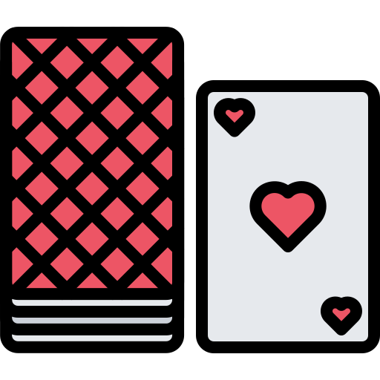
Project: Deck Class

For this project, you will create a class that contains a deck of playing cards with the ability to manipulate the cards in the deck in several ways.

Arrays (not Lists)

Do not use Python lists in this project. Anywhere you feel like a list would be useful, use an Array object instead. The Array class is provided in arrays.py.

Representing the Cards

The cards inside your deck class will be stored as an array. Each card is represented by a 2-character sequence. For instance:

Card | Character Representation
2 of Hearts | 2H
3 of Clubs | 3C
Queen of Diamonds | QD
Ace of Spades | AS

So, this set of cards:

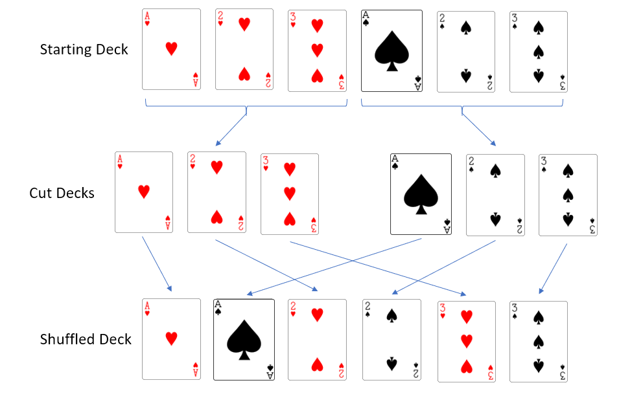

Would be represented as this array (index 0 is on the left):

[“AH”, “2H”, “3H”, “AS”, “2S”, “3S”]

Note that this convention is used in the provided examples and files, but there are no requirements to ensure that it is followed. So, you could use the array [“A”, “B”, “C”] as an array of cards and the class should work fine.

Loading a Deck From a File

Included with the starter files are several sets of cards to use for testing, main.py, and helpers.py. main() makes use of the function fileToArray(string) which is already written in helpers.py. fileToArray(string) will read the contents of a file named in the given string into an array and return that array.

Once you’ve written the Deck class as described below, the array returned from fileToArray() can be used to load a Deck object with cards:

deck = Deck(fileToArray(testFile))

Or if the Deck object already exists, it can be loaded with new cards using load():

deck.load(fileToArray(testFile))

Included with the starter files are several “decks” you can load for testing:
- evendeck.txt – An even size deck of 10 cards.
- odddeck.txt – An odd size deck of 11 cards.
- onecard.txt – A single card.
- fulldeck.txt – A full deck of 52 cards.

The Deck Class

Your program will include the class Deck that stores and manipulates a deck of cards. The file containing the Deck class must be named deck.py. The cards must be stored inside the Deck objects in an Array.

Your Deck class must make member variables private.

The Deck class must include these member functions, though you’re welcome to add additional functions if helpful:

__init__(array)

The array parameter contains the starting cards to be placed into the deck. Individual elements should be copied from the array parameter into an array which is a member of the class to avoid altering the array outside the function. The array parameter is required, there is no such thing as an empty deck.

__str__(): string

Returns the contents of the deck as a string. The string must be the cards in the deck in order with a single space between them. There should be no space or line break at the end of the string.

Example:
Deck containing array: [“AH”, “2H”, “3H”, “AS”, “2S”, “3S”]

__str__() => “AH 2H 3H AS 2S 3S”

size(): int

Returns the number of cards in the deck.

Example:
Deck containing array: [“AH”, “2H”, “3H”, “AS”, “2S”, “3S”]

size() => 6
load(array)

Replaces the current array stored in the deck with the “cards” in the provided array parameter. Individual elements should be copied from the array parameter to avoid altering the array outside the function.
cutTop(): array

Returns the top half of the deck as an array. The top half of the deck is defined as the floor of the number of cards divided by 2. So, for a deck of 10 cards, the top is the first 5 cards. For a deck of 9 cards, the top is the first 4 cards. For a deck of 1 card, the top is 0 cards.

Example:
Deck containing array: [“AH”, “2H”, “3H”, “AS”, “2S”, “3S”]

cutTop() => [“AH”, “2H”, “3H”]
cutBottom(): array

Returns the bottom half of the deck as an array. The bottom half of the deck is defined as the ceiling of the number of cards divided by 2. So, for a deck of 10 cards, the bottom is the last 5 cards. For a deck of 9 cards, the bottom is the last 5 cards. For a deck of 1 card, the bottom is 1 card.

Example:
Deck containing array: [“AH”, “2H”, “3H”, “AS”, “2S”, “3S”]

cutBottom() => [“AS”, “2S”, “3S”]
rotate()

Updates the array contained in the deck by taking the bottom half of the deck and placing it before the top half of the deck in the array. See cutTop() and cutBottom() for the definition of top and bottom.

Example:
Initial deck array: [“AH”, “2H”, “3H”, “AS”, “2S”, “3S”]

Rotated deck array: [“AS”, “2S”, “3S”, “AH”, “2H”, “3H”]
reverse()

Updates the array contained in the deck by reversing the order of the cards stored in the deck.

Example:
Initial deck array: [“AH”, “2H”, “3H”, “AS”, “2S”, “3S”]

Reversed deck array: [“3S”, “2S”, “AS”, “3H”, “2H”, “AH”]
shuffle()

Updates the array contained in the deck by shuffling it. See details in the “Shuffling” section below.

Shuffling

We will perform what is called a perfect out-shuffle which retains the top and bottom card from the starting deck as the top and bottom card of the shuffled deck.

- Split, or “cut”, the starting deck into 2 pieces: top and bottom. See cutTop() and cutBottom() for the definition of top and bottom. Set counters i and j to zero.

- Select the card i from top, add it to the shuffled deck. Increment i.

- Select the card j from bottom, add it to the shuffled deck. Increment j.

- Repeat steps 2 and 3 as long as i is a valid index in top and j is a valid index in bottom.

- If any cards remain in the bottom, add them to the shuffled deck. If the above steps are done correctly, there should be a maximum of 1 card remaining in the bottom in the scenario where the original deck had an odd number of cards.

Here is an illustration of forming the shuffled deck with a 6 card starting deck:



Whether the deck has an even number of cards or an odd number of cards, the first and last card of the shuffled deck will be the same as the starting deck.

Note that for an odd size deck, the last two cards in the shuffled deck will be from the bottom portion of the original deck:

Starting deck: [“AH”, “2H”, “2S”, “3S”, “4H”]
Shuffled deck: [“AH”, “2S”, “2H”, “3S”, “4H”]

This occurs because the top and bottom half of the decks do not have the same number of cards in an odd size deck.

Additional Requirements

- Use good, meaningful variable names.
- Follow proper programming and object-oriented programming techniques.
- Code in a neat, readable manner including appropriate use of whitespace/blank lines to increase readability. Treat blank lines like you would paragraph breaks in English. Group your statements into logical blocks with a blank line in between.
- Comment all classes and functions with docstrings per instructions in the slides for section 1.4. Include appropriate explanatory comments inside functions.
- Avoid duplication of code. If essentially the same algorithm is used in multiple places, that algorithm should probably be placed inside its own function.
- Provide neat, orderly, and readable output. In particular, grading may rely on you matching the required output formatting exactly.

